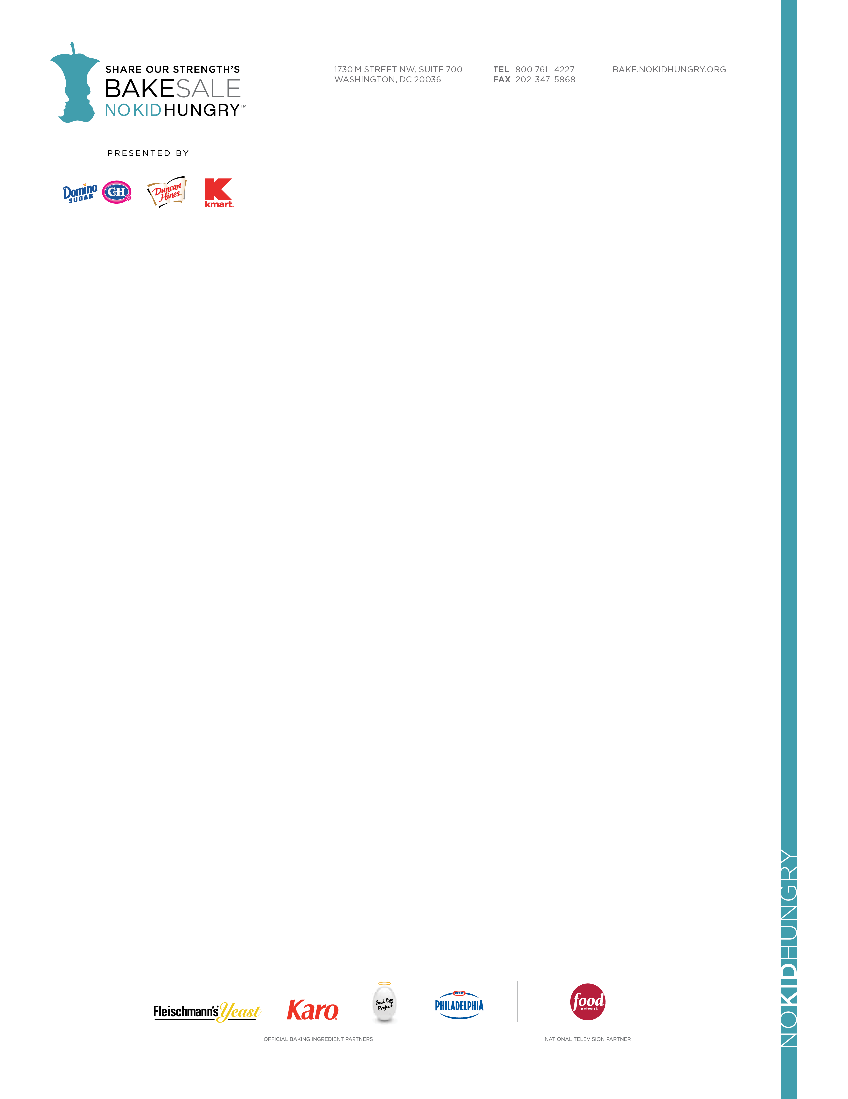

MEDIA ALERT *** MEDIA ALERT *** MEDIA ALERT *** MEDIA ALERT

FOR IMMEDATE RELEASE
FOR IMMEDIATE RELEASE
Contact: Contact[INSERT YOUR NAME]
[INSERT YOUR Cell PHONE NUMBER]
[INSERT YOUR E-MAIL]

[INSERT YOUR NAME OR BAKE SALE NAME] Holds Bake Sale to End Childhood Hunger in [INSERT YOUR CITY OR STATE]

Bake Sale Part of Share Our Strength’s Bake Sale for No Kid Hungry™, a National Campaign to end childhood hunger in America

Who: [INSERT YOUR NAME OR TEAM NAME] is joining millions of people across the country who are making a difference by joining the fight against childhood hunger in America. It’s a simple as hosting a bake sale.

What: [INSERT YOUR NAME OR TEAM NAME] is/are having bake sale, as part of Share Our Strength’s Bake Sale for No Kid Hungry, a national campaign that encourages individuals to host bake sales in their communities to help end childhood hunger in America.

[INSERT BAKE SALE EVENT DETAILS LIKE THE KINDS OF BAKED GOODS BEING SOLD OR OTHER NOTABLE EVENT ACTIVITIES]

When: [INSERT BAKE SALE DATE AND TIME]

Where: [INSERT BAKE SALE LOCATION]

Details: This year, nearly 1 in 5 children across the country struggle with hunger. That’s more than 16 million kids. Funds raised through [INSERT YOUR NAME OR TEAM NAME] Bake Sale for No Kid Hungry will be used to support Share Our Strength’s efforts to end childhood hunger in America. Share Our Strength works to surround kids facing hunger with nutritious food where they live, learn and play.

About Share Our Strength’s bake Sale for No Kid Hungry
Share Our Strength's Bake Sale for No Kid Hungry™, presented by Domino® Sugar, C&H® Sugar, Duncan Hines® and Kmart®, is a national fundraising initiative that encourages people to host bake sales in their communities to support Share Our Strength’s No Kid Hungry® campaign, to end childhood hunger in America. Since 2003, more than 1.4 million people have participated in Bake Sale for No Kid Hungry, raising more than $9.6 million to make sure there is no kid hungry in America. Bake Sale for No Kid Hungry is supported by national television partner Food Network and official baking ingredient partners Karo® corn syrup, Fleischmann’s® yeast, PHILADELPHIA cream cheese and the Good Egg Project. Visit Bake.NoKidHungry.org.

About Share Our Strength
No child should grow up hungry in America, but one in five children struggles with hunger. Share Our Strength’s No Kid Hungry® campaign is ending childhood hunger in America by ensuring all children get the healthy food they need, every day. The No Kid Hungry campaign connects kids in need to effective nutrition programs like school breakfast and summer meals and teaches low-income families to cook healthy, affordable meals through Cooking Matters. This work is accomplished through the No Kid Hungry network, made up of private citizens, public officials, nonprofits, business leaders and others providing innovative hunger solutions in their communities. Join us at NoKidHungry.org.

